Cairo university  
Faculty of engineering  
Computer engineering department  
Machine Learning [**CMP4040**]   
Project Report

**Web page  
 Phishing Detection**

**Team 9**

|  |  |  |
| --- | --- | --- |
| Name | section | BN |
| احمد أسعد درويش محمد درويش | 1 | 1 |
| عمر فريد عبد العاطى لملوم | 2 | 4 |
| محمد نبيل عبد الفتاح فهمى | 2 | 19 |
| ممدوح احمد محمد محمد عطيه | 2 | 27 |

Presented to:

**Eng. Mohamed Shawky**

# Workload Division

|  |  |
| --- | --- |
| Name | Workload |
| احمد أسعد درويش محمد درويش | Data Preprocessing |
| عمر فريد عبد العاطى لملوم | Data Preprocessing |
| محمد نبيل عبد الفتاح فهمى | Models |
| ممدوح احمد محمد محمد عطيه | Models |

# Problem definition & Motivation

**Phishing** continue s to prove one of the most successful and effective ways for cybercriminals *to defraud us and steal our personal and financial information*.

**Our growing reliance** on the internet to conduct much of our day-to-day business has provided fraudsters with the perfect environment to launch targeted phishing attacks. The phishing attacks taking place today are sophisticated and increasingly more difficult to spot. A study conducted by Intel found that 97% of security experts fail at identifying phishing emails from genuine emails.

So in our ML project we would like to address this problem by training 3 phishing detection models and apply our knowledge to evaluate these using the following metrics for example:

# Evaluation metrics

Here are some of our proposed metrics (subject to add more of them – will be clarified in the final report إن شاء الله )

1. Accuracy
2. Confusion Matrix
   * which in turn include:
     1. TP : True positives
     2. TN : True Negatives
     3. FP : False positives
     4. FN : False negatives
3. F1 – Score
4. Precision
5. Recall

# Dataset Link

The dataset that we propose to use:

<https://www.kaggle.com/datasets/shashwatwork/web-page-phishing-detection-dataset?resource=download>

# #1 : Dataset analysis

Let's talk about dataset analysis in the upcoming bullet-points

1. At first , we loaded the dataset from Kaggle site.
2. Explore the dataset : **info** – **description** – **shape.**
3. Data preprocessing : Drop duplicates – Drop nulls [There weren't any of these in our dataset]
4. Dataset visualization :
   1. **Histogram of features** : They gave me some insights about the feature values ranges and frequencies. Also you can notice that Many features are regex features 🡺 The majority of values are zero , and they take that values 0 or 1. At first I thought about dropping them , but said that they may turn to have useful information even if small.

صورة تحتوي على لقطة شاشة, رسم بياني, دائرة, الخط

تم إنشاء الوصف تلقائياً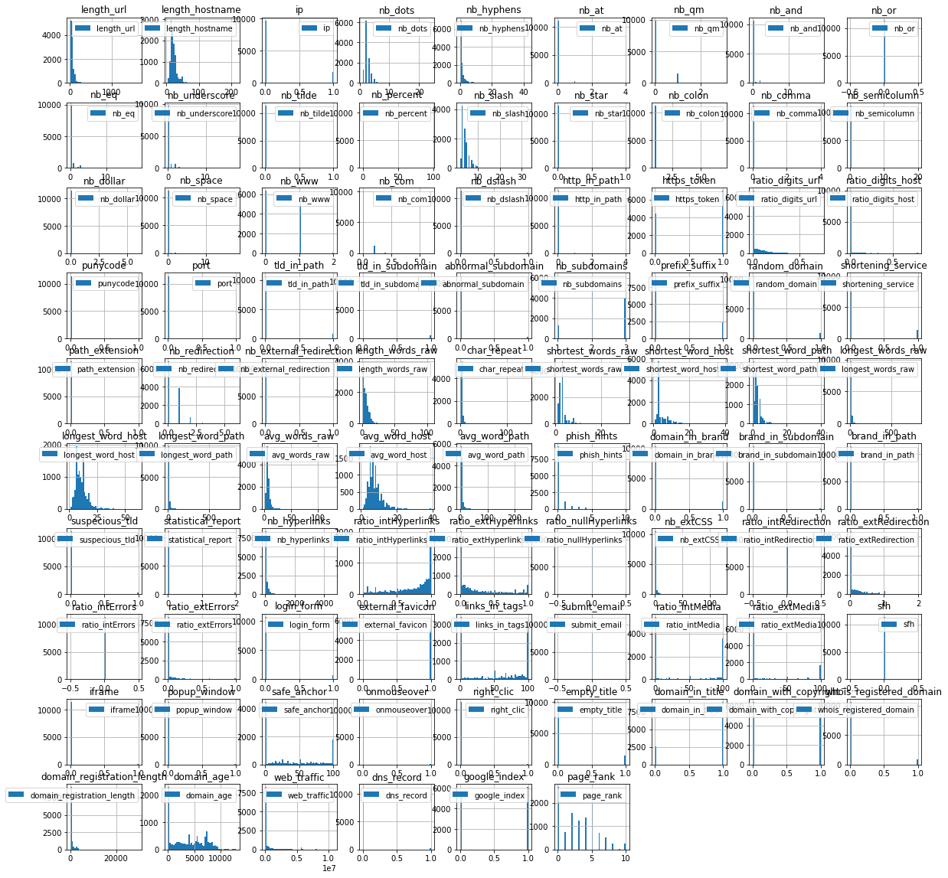

* 1. Pie chart of the output variable
     1. Concluded that **the dataset is balanced.**
  2. Correlation matrix

صورة تحتوي على نص, خط, لقطة شاشة, شكل

تم إنشاء الوصف تلقائياً

* 1. Correlation with the output variable yielded the following graph:

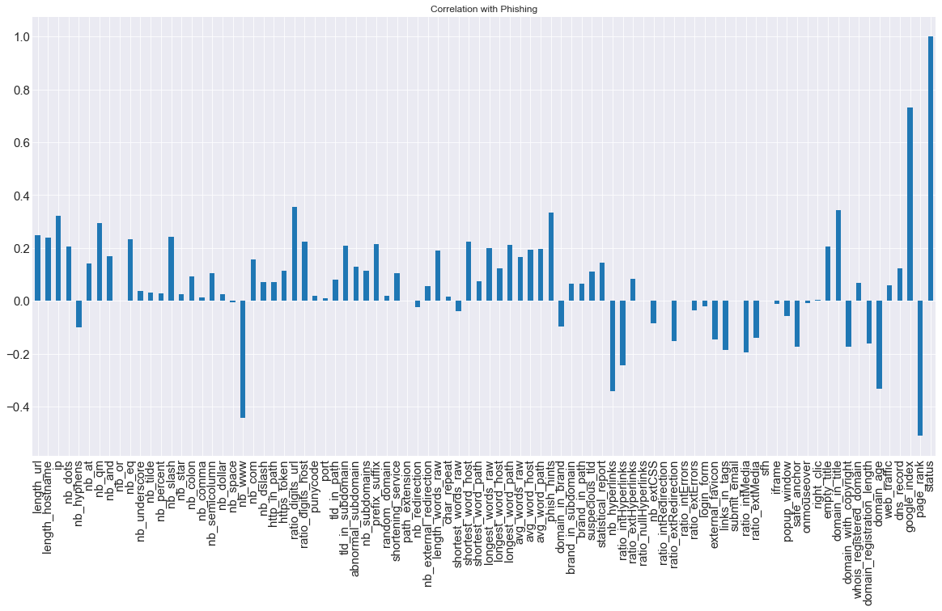

There were 2 experiments made , we will show the results before and after dropping the lowly correlated features (with target correlation < 0.1) in the experiments section below.

Anyway , after dropping the columns with correlation in range [ -1 : 1 ], here are the rest of the features after dropping these columns:

صورة تحتوي على نص, لقطة شاشة, تخطيط, الخط

تم إنشاء الوصف تلقائياً

Top 5 features with the highest correlation with the output variable

google_index 0.731171

page_rank 0.511137

nb_www 0.443468

ratio_digits_url 0.356395

domain_in_title 0.342807

* 1. Box Plot (To analyze outliers)

صورة تحتوي على لقطة شاشة, مستطيل, نص, ميدان/ مربع

تم إنشاء الوصف تلقائياً

Woah ! umm well this is hard to view :)

Some important notes from the box plot are:

1. The feature : "web_traffic" has a lot of outliers.=> to solve this we can use log transformation.

2. Features ranges are different.=> to solve this we can use standardization.

Also , looks like the features needs scaling. :)

* 1. Took random data sample to view (please refer to notebook for full row view:

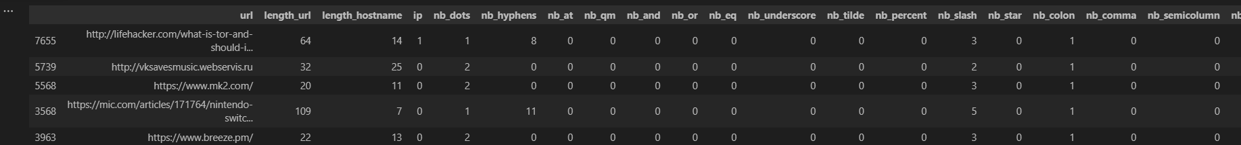

1. Data preprocessing:
   1. We have to convert the categorical data into numerical data

## the only categorical data are the target column and the url column

# we will convert the target column to numerical data

#by mapping the values : 1 for phishing and 0 for legitimate

* 1. The url column is not useful for the model so we will drop it
  2. Scaling the features using a StandardScaler.
  3. Fix the web_traffic column values
     1. we will use the median value to replace the negative values

now it looks like this:

صورة تحتوي على لقطة شاشة, مستطيل, خط, نص

تم إنشاء الوصف تلقائياً

* 1. Redrawing BoxPlot after the scaling and fixing

صورة تحتوي على لقطة شاشة, خط

تم إنشاء الوصف تلقائياً

A bit better and the boxes are more apparent . For Better visualization kindly run the corresponding cell and open the plot from the cell and zoom in like this:

صورة تحتوي على لقطة شاشة, نص, رسم بياني, خط

تم إنشاء الوصف تلقائياً

At first it came to my mind to remove the remaining outliers. But after searching I decided to keep them because they are important for the model to learn the patterns, and gain insights from the data.

# #2 Experiments & Results

Experiment #1 : Without dropping low correlated features:

Experiment #2 : After dropping low correlated features (no hyperparameter tuning experiment):

Models accuracies:

صورة تحتوي على نص, لقطة شاشة, الخط, رقم

تم إنشاء الوصف تلقائياً

Cross validation scores:

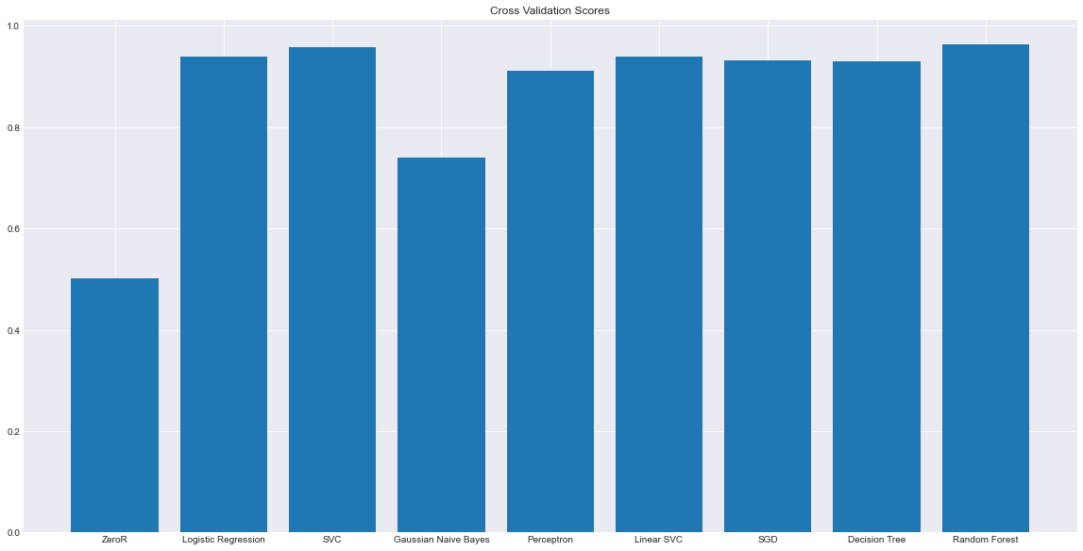

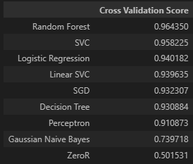

Cross validation scores [no hyperparameters tuning]:

صورة تحتوي على نص, لقطة شاشة, مستطيل, موازِ

تم إنشاء الوصف تلقائياً

Models

=============================================

1. **Ensemble Learning**
   1. **Bagging**

Using the following estimators:  
  
estimators=[('zeroR',zero_r),('logreg', logreg), ('svc', svc), ('gaussian', gaussian), ('perceptron', perceptron), ('linear_svc', linear_svc), ('sgd', sgd), ('decision_tree', decision_tree), ('random_forest', random_forest)]

The accuracy is: **0.9597550306211724**

Another Experiment on the best 5 classsifier in the voting classifier

Using the following estimators:  
  
estimators=[('logreg', logreg), ('svc', svc), ('linear_svc', linear_svc), ('sgd', sgd), ('random_forest', random_forest)]

The accuracy is: **0.9545056867891514**

So random forest accuracy is better than ensemble learning Boosting

Which is logical :) they are't weak learners , not

1. **Boosting**

Using AdaboostClassifier and RandomForest estimator:  
  
adaboost = AdaBoostClassifier(RandomForestClassifier(), n_estimators=5)

The accuracy is: **0.9676290463692039**

—-------

1. ZeroR: as a baseline

zero_r = DummyClassifier(strategy='most_frequent', random_state=12)

F1 Score: 0.3331388564760793

Confusion Matrix:

 [[   0 1157]

 [   0 1129]]

Classification Report:

               precision    recall  f1-score   support

        -1.0       0.00      0.00      0.00      1157

         1.0       0.49      1.00      0.66      1129

    accuracy                           0.49      2286

   macro avg       0.25      0.50      0.33      2286

weighted avg       0.24      0.49      0.33      2286

صورة تحتوي على لقطة شاشة, ميدان/ مربع, التلون, رسم بياني

تم إنشاء الوصف تلقائياً

logistic regression:

logreg = LogisticRegression()

Logistic Regression Accuracy: 0.9501312335958005

[[1102   55]

 [  59 1070]]

              precision    recall  f1-score   support

        -1.0       0.95      0.95      0.95      1157

         1.0       0.95      0.95      0.95      1129

    accuracy                           0.95      2286

   macro avg       0.95      0.95      0.95      2286

weighted avg       0.95      0.95      0.95      2286

صورة تحتوي على لقطة شاشة, ميدان/ مربع, التلون, خط

تم إنشاء الوصف تلقائياً

Support Vector Machines+ Hyperparameter tuning:

svc = SVC()

#hyperparameters for SVM are:

# C: regularization parameter

# kernel: specifies the kernel type to be used in the algorithm

# linear: linear kernel

# poly: polynomial kernel

# rbf: radial basis function kernel

# sigmoid: sigmoid kernel

# degree: degree of the polynomial kernel function

# gamma: kernel coefficient for rbf, poly and sigmoid

# random_state: seed for random number generator

C = [0.1, 1, 10, 100]

kernel = ['linear', 'poly', 'rbf', 'sigmoid']

degree = [3, 4, 5]

gamma = ['scale', 'auto']

SVM Accuracy: 0.9667541557305337

[[1123   34]

 [  42 1087]]

              precision    recall  f1-score   support

        -1.0       0.96      0.97      0.97      1157

         1.0       0.97      0.96      0.97      1129

    accuracy                           0.97      2286

   macro avg       0.97      0.97      0.97      2286

weighted avg       0.97      0.97      0.97      2286

صورة تحتوي على لقطة شاشة, ميدان/ مربع, التلون, خط

تم إنشاء الوصف تلقائياً

Gaussian Naive Bayes:

gaussian = GaussianNB()

Gaussian Naive Bayes Accuracy: 0.7462817147856518

[[1127   30]

 [ 550  579]]

              precision    recall  f1-score   support

        -1.0       0.67      0.97      0.80      1157

         1.0       0.95      0.51      0.67      1129

    accuracy                           0.75      2286

   macro avg       0.81      0.74      0.73      2286

weighted avg       0.81      0.75      0.73      2286

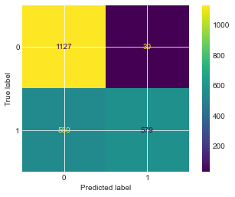

Perceptron + Hyperparameter tuning :

Hyperparameter tuning :

1- Perceptron:

list of hyperparameters

**penalty** : l1 or l2 : The penalty (aka regularization term) to be used

**alpha** : float : Constant that multiplies the regularization term. The higher the value, the stronger the regularization

**max_iter** : int : The maximum number of passes over the training data (aka epochs)

**tol** : float : The stopping criterion. If it is not None, the iterations will stop when (loss > previous_loss - tol)

**early_stopping** : bool : Whether to use early stopping to terminate training when validation score is not improving

**validation_fraction** : float : The proportion of training data to set aside as validation set for early stopping

**n_iter_no_change** : int : Number of iterations with no improvement to wait before stopping

**shuffle** : bool : Whether to shuffle training data before each iteration

Tested the following values:

penalty = ['l1', 'l2']

alpha = [0.0001, 0.001, 0.01, 0.1, 1, 10, 100]

max_iter = [100, 1000, 10000]

tol = [1e-3, 1e-4, 1e-5]

early_stopping = [True, False]

validation_fraction = [0.1, 0.2, 0.3]

n_iter_no_change = [5, 10, 15]

shuffle = [True, False]

Used the **RandomizedSearchCV**

**perceptron_random = RandomizedSearchCV(estimator = perceptron, param_distributions = random_grid, n_iter = 100, cv = 3, verbose=2, random_state=42, n_jobs = -1)**

perceptron = Perceptron()

perceptron_random = RandomizedSearchCV(estimator = perceptron, param_distributions = random_grid, n_iter = 100, cv = 3, verbose=2, random_state=42, n_jobs = -1)

Fitting 3 folds for each of 100 candidates, totalling 300 fits

{'validation_fraction': 0.1, 'tol': 0.001, 'shuffle': True, 'penalty': 'l1', 'n_iter_no_change': 10, 'max_iter': 1000, 'early_stopping': False, 'alpha': 0.0001}

best params: {'validation_fraction': 0.1, 'tol': 0.001, 'shuffle': True, 'penalty': 'l1', 'n_iter_no_change': 10, 'max_iter': 1000, 'early_stopping': False, 'alpha': 0.0001}

Perceptron Accuracy: 0.9269466316710411

[[1085   72]

 [  95 1034]]

              precision    recall  f1-score   support

        -1.0       0.92      0.94      0.93      1157

         1.0       0.93      0.92      0.93      1129

    accuracy                           0.93      2286

   macro avg       0.93      0.93      0.93      2286

weighted avg       0.93      0.93      0.93      2286

صورة تحتوي على لقطة شاشة, ميدان/ مربع, التلون, رسم بياني

تم إنشاء الوصف تلقائياً

Linear SVC:

linear_svc = LinearSVC(max_iter=10000, dual=False)

Linear SVC Accuracy: 0.9510061242344707

[[1103   54]

 [  58 1071]]

              precision    recall  f1-score   support

        -1.0       0.95      0.95      0.95      1157

         1.0       0.95      0.95      0.95      1129

    accuracy                           0.95      2286

   macro avg       0.95      0.95      0.95      2286

weighted avg       0.95      0.95      0.95      2286

صورة تحتوي على لقطة شاشة, ميدان/ مربع, التلون, خط

تم إنشاء الوصف تلقائياً

Stochastic Gradient Descent:

sgd = SGDClassifier()

SGD Accuracy: 0.9426946631671042

[[1085   72]

 [  59 1070]]

              precision    recall  f1-score   support

        -1.0       0.95      0.94      0.94      1157

         1.0       0.94      0.95      0.94      1129

    accuracy                           0.94      2286

   macro avg       0.94      0.94      0.94      2286

weighted avg       0.94      0.94      0.94      2286

صورة تحتوي على لقطة شاشة, ميدان/ مربع, التلون, خط

تم إنشاء الوصف تلقائياً

Decision Tree:

decision_tree = DecisionTreeClassifier()

Decision Tree Accuracy: 0.9313210848643919

[[1081   76]

 [  81 1048]]

              precision    recall  f1-score   support

        -1.0       0.93      0.93      0.93      1157

         1.0       0.93      0.93      0.93      1129

    accuracy                           0.93      2286

   macro avg       0.93      0.93      0.93      2286

weighted avg       0.93      0.93      0.93      2286

صورة تحتوي على لقطة شاشة, ميدان/ مربع, التلون, خط

تم إنشاء الوصف تلقائياً

Random Forest:

random_forest = RandomForestClassifier(n_estimators=100)

Random Forest Accuracy: 0.968066491688539

[[1128   29]

 [  44 1085]]

              precision    recall  f1-score   support

        -1.0       0.96      0.97      0.97      1157

         1.0       0.97      0.96      0.97      1129

    accuracy                           0.97      2286

   macro avg       0.97      0.97      0.97      2286

weighted avg       0.97      0.97      0.97      2286

صورة تحتوي على لقطة شاشة, ميدان/ مربع, التلون, خط

تم إنشاء الوصف تلقائياً